40.38: a)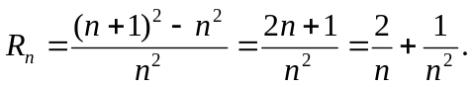
This is never larger than it is for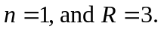 b) R approaches zero; in the classical limit, there is no quantization, and the spacing of successive levels is vanishingly small compared to the energy levels.

